Write a program that accepts the job_id as argument and returns a custom counter and a system counter (total records input to the map tasks) associated with that job.

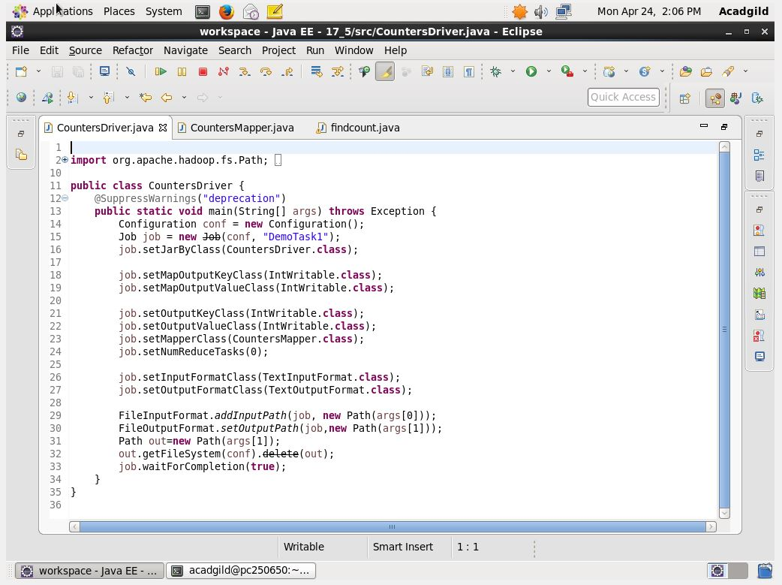

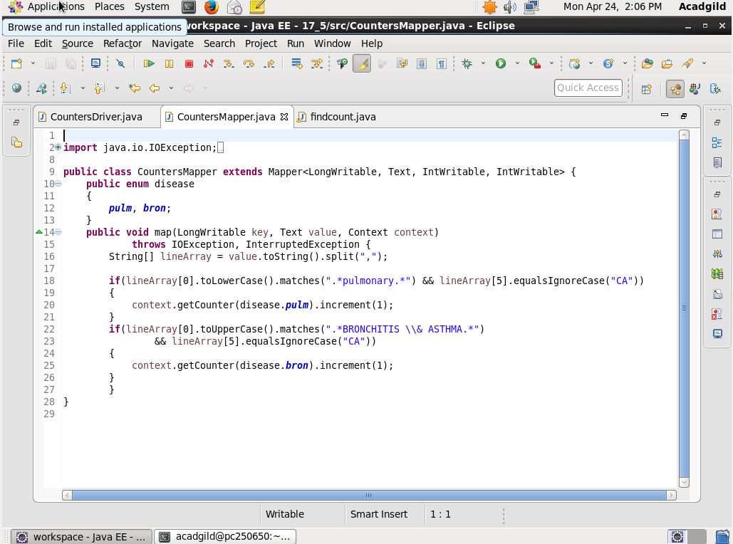

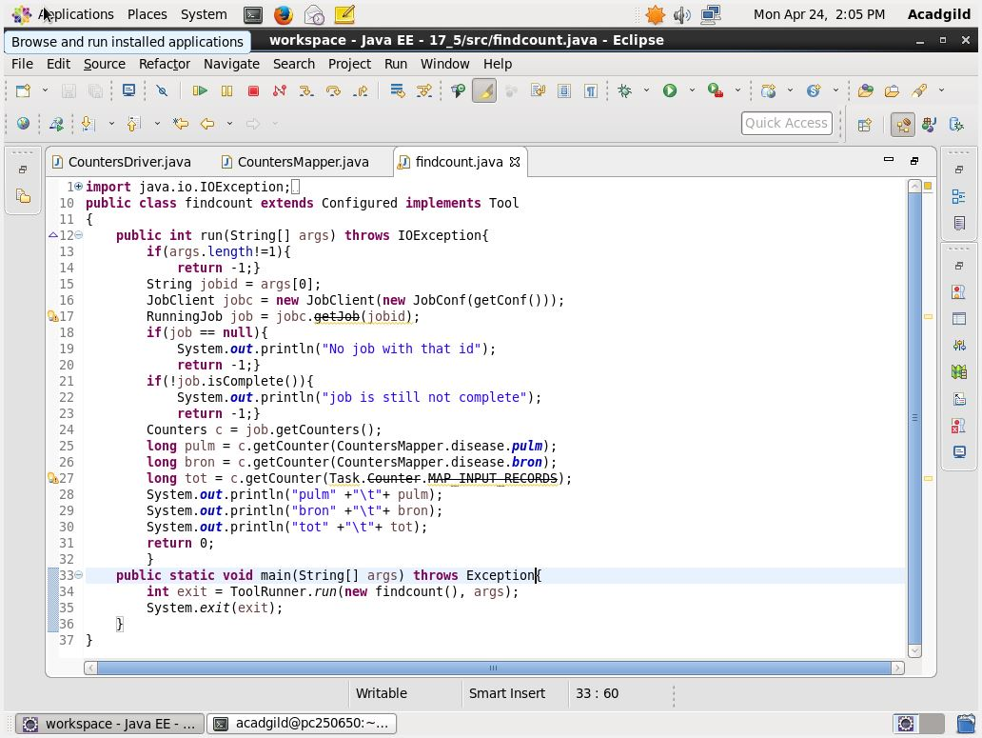

For history server to start we need to give the command

Mr-jobhistory-daemon.sh start historyserver

